TICTACTOE PROJECT

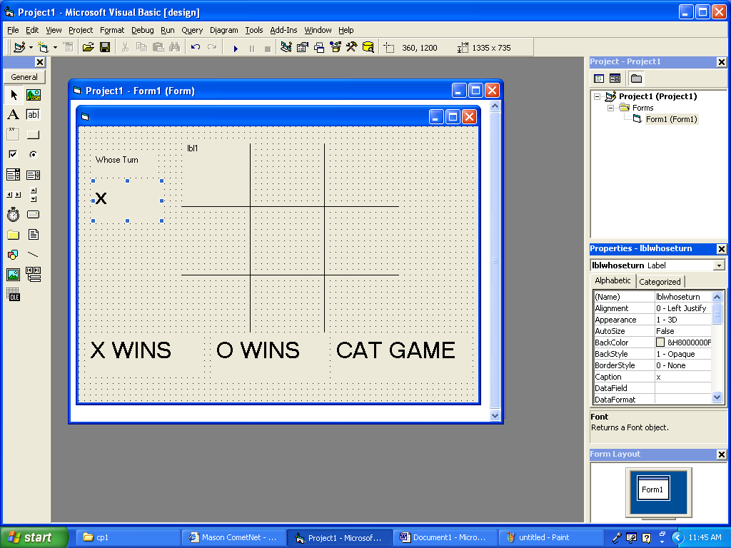

Private Sub lbl1_Click()
'play game
If lbl1 = "" Then
If lblwhoseturn = "x" Then
lbl1 = "x"
lblwhoseturn = "o"

Else
lbl1 = "o"
lblwhoseturn = "x"
End If
End If
'check to see if someone wins or ends game
If lbl3 = "x" And lbl2 = "x" And lbl1 = "x" Then
lblxwins.Visible = True
‘disable
‘lineth.visible=true
‘tmrxwins.enabled=true
‘lblnumxwins=val(lblnumxwins)+1
ElseIf lbl7 = "x" And lbl4 = "x" And lbl1 = "x" Then
lblxwins.Visible = True
'...all the other ways to end game by clicking on lbl1 last including cat game
End If
End Sub

